a27 manifesto

To share

apartment, 120 square meters, on carrer Avinyó corner with Comdessa Sobradiel
(Gothic quarter-BARCELONA-MEDITERRANEAN Sea-SouthEUROPA).

a hybrid space surroundin an internal courtyard
(storageroom-pantry.kitchen.wc.bathroom.livingroom-diningroom-study-bedroom)
and two individual rooms with balconies.

a place for REST.STUDY.SLEEP

cold in winter, hot in summer,
sunny from spring to the start of autumn,
with Water and Electricity, refrigerator.water-heater(50l).electric-heater.
washingmachine.vacuumcleaner.telephone-fax.soundsystem.tvmonitor.vhsplayer
without Air-conditioning, heating or extractor fan
Wooden floor, furnished according to needs,
home library specialised in ART-PHILOSOPHY-SCIENCE-METAPHYSICS.

conditions of the space:

Economy-Ecology-Ethics
austerity, comfort, practical common sense
consume and use of mainly ecological food and products
simple vegetarian/semi-vegetarian cooking
tidiness and weekly cleaning
recycling: paper, glass, plastics, ...
daytime living

a SUSTAINABLE space

TOTAL COST: 500 €/month (including vat and all services except telephone)
to be divided between the number of people sharing the space
and the accommodation type (individual room-livingroom.study.diningroom.bedroom).

PERIODS long, medium and short-term and transient stays;
continuous and intermittent.

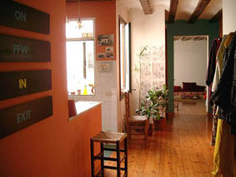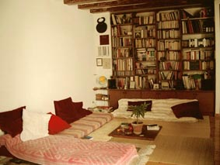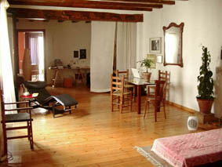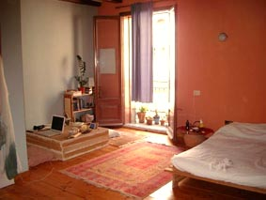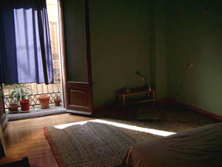
entrance hybrid space room 2 room 1

for
responsible people,
who respect silence and the repose of others.
non-smokers or moderate smokers.

contact neus phone/fax 00-34-93 310 06 47 nbf@quelcom.net

